Hoe kan ik de domain-naam automatisch inlezen?

[Identity](https://technet.microsoft.com/en-us/library/ee617224.aspx?f=255&MSPPError=-2147217396)

Specifies an Active Directory domain object by providing one of the following property values. The identifier in parentheses is the LDAP display name for the attribute. All values are for the domainDNS object that represents the domain.  
  
Distinguished Name  
Example: DC=redmond,DC=corp,DC=contoso,DC=com

* <https://blogs.msmvps.com/richardsiddaway/2012/01/21/get-the-domain-distinguished-name/>

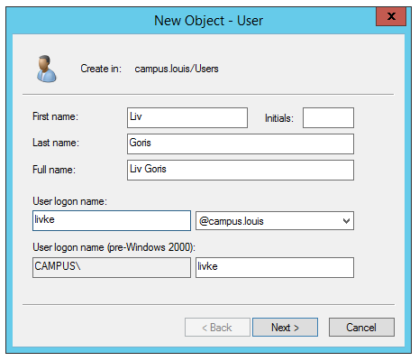

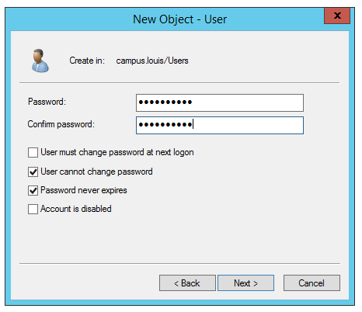

Zie beter in het volgende voor die UPN en sam ed….

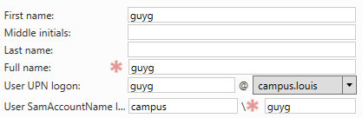

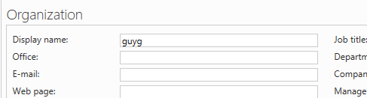

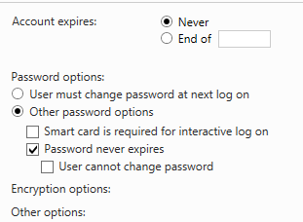

<http://techgenix.com/creating-active-directory-accounts-using-powershell/>

[New-ADUser](https://technet.microsoft.com/en-us/library/ee617253.aspx)

* *Name*
* *AccountPassword*
* *CannotChangePassword*
* *ChangePasswordAtLogon*
* *Description*
* *DisplayName*
* *GivenName*
* *HomeDirectory*
* *OtherAttributes*
* *PasswordNeverExpires*
* *PasswordNotRequired*
* *Path*
* *ProfilePath*
* *SamAccountName*
* *Surname*
* *UserPrincipalName*

Enkele leuke links

<https://community.spiceworks.com/topic/2035558-creating-bulk-users-in-active-directory-using-powershell-import-csv>

<https://social.technet.microsoft.com/wiki/contents/articles/24541.powershell-bulk-create-ad-users-from-csv-file.aspx>

<http://activedirectoryfaq.com/2016/04/ad-powershell-basics-new-aduser/>

<http://techgenix.com/creating-active-directory-accounts-using-powershell/>

<http://www.itprotoday.com/management-mobility/use-powershell-handle-active-directory-paths>

<https://technet.microsoft.com/en-us/library/ee617236.aspx?f=255&MSPPError=-2147217396>